GAD’s

And

CPE’s

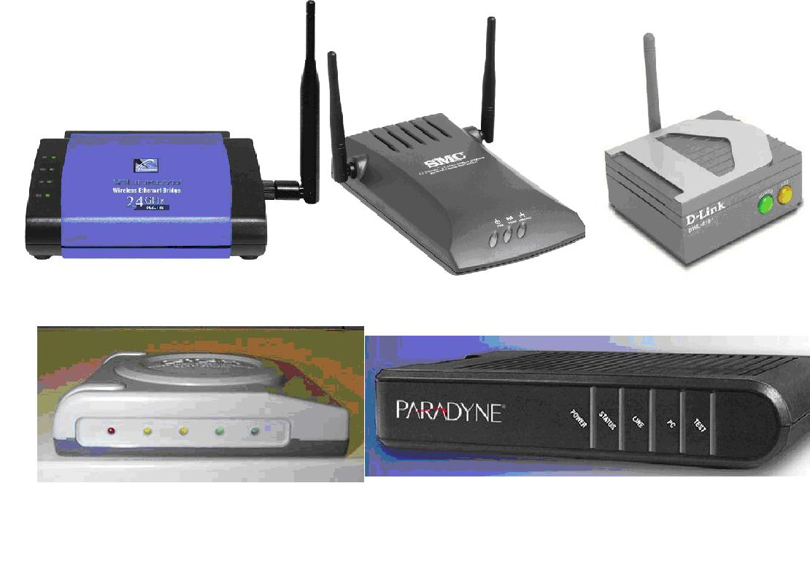
ASUS GAD

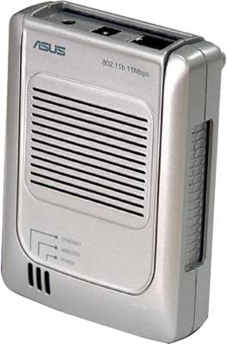

Power – on or off
Wireless – on if associated, off if not associated, and flashing if it is sending and receiving data
Ethernet – on if connected, off if not connected.
Linksys WET11 GAD (all lights are green)
Power: solid
Diag: off
LAN: solid if connected, flickering when there is activity
WLAN: solid if connected, flickering when there is activity
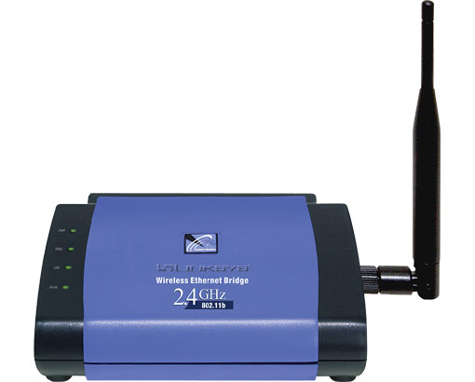

D-Link GAD
Power: solid (green)
ACT or WLAN: solid if connected, flickering when there is activity (orange)
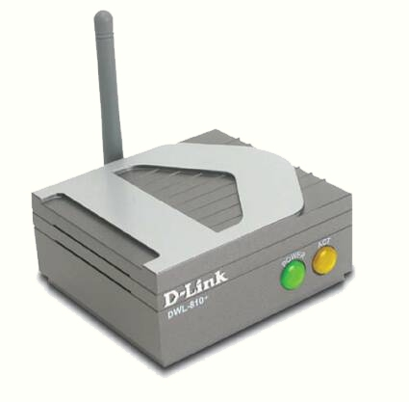
SMC GAD
Power: solid
Link/Act (Ethernet): solid if connected, flickering when there is activity
TX/RX (wireless): solid if connected, flickering when there is activity
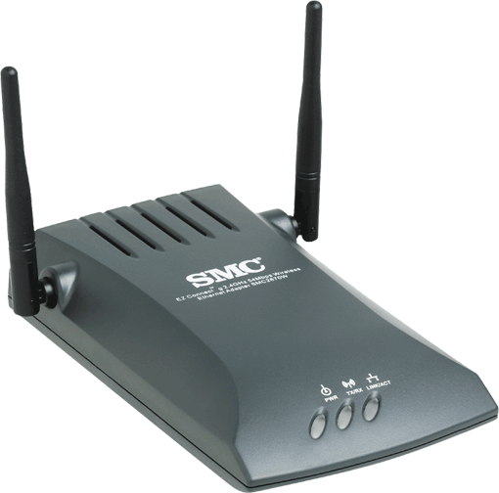
OTC GAD

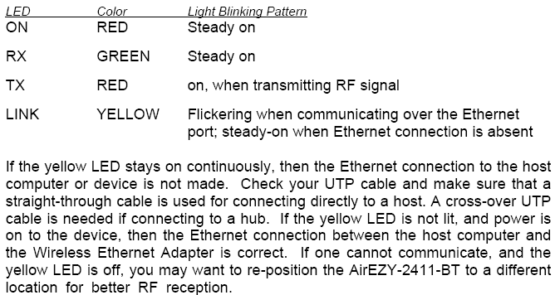

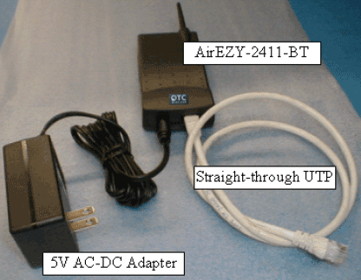
Gigalink DSL CPE
Power: solid (red)
Link: solid (yellow/orange)
LAN: solid (yellow/orange)
Rx: flickering when there is activity (green)
Tx: flickering when there is activity (green)
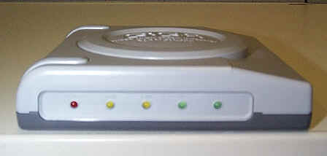
 | Power | Link | LAN | RX | TX
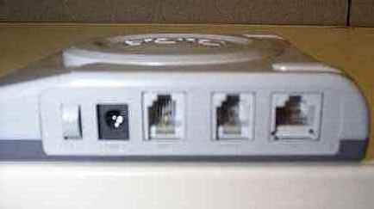
 | On/Off | Power | Line | Phone | LAN

Netopia Cayman DSL CPE (all lights are green)
Ethernet Link: solid
Ethernet Traffic: flickering when there is activity
DSL Traffic: flickering when there is activity
DSL sync: solid
USB Active: off
Power: solid
This CPE has a reset button that can and should be used if needed.
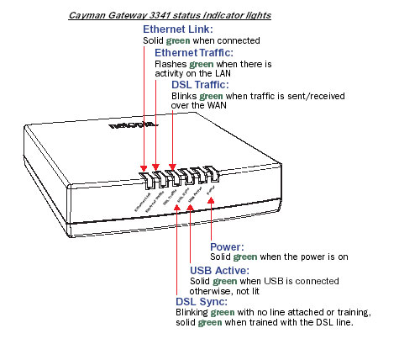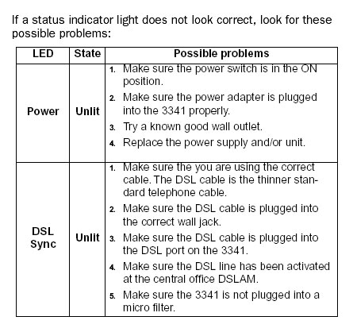
Paradyne 6210 DSL CPE (all lights are green)
Power: solid
Status: flashing while establishing DSL connection, solid with DSL link
Line: flickering when there is activity
PC: solid
Test: off
This CPE has a reset button that can and should be used when needed.

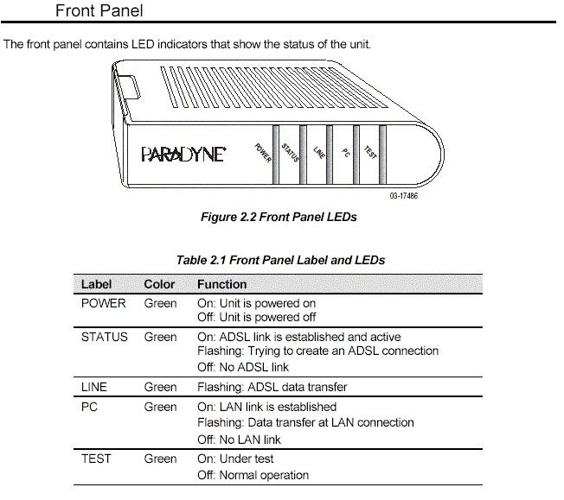
Turbocomm EA110 ADSL CPE

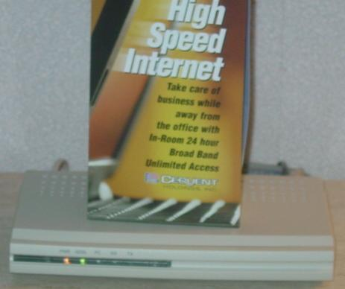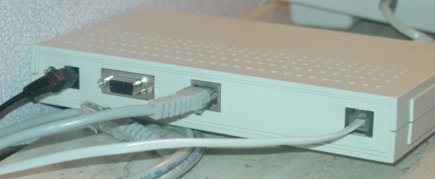
The ADSL light will flash on these CPEs regardless of whether the phone cord is plugged in. If there is no phone cord connected, or if the modem does not see the Paradyne, then the ADSL light will flash steadily about every 3 seconds. If there is a phone cord connected, and the modem is trying to establish a DSL link, the light will flash more rapidly for a period of time. If it cannot establish a link, it will then go off for a period, and then start flashing rapidly again. If it does establish a link, it will go solid. This is different from the other DSL modems we support which do not blink until there is a good phone line connected, so for these CPEs we need to be sure to verify the phone cord is securely connected.
Paradyne 5620 CPE – Hawaiian Village (Tapa and Rainbow)
PWR: solid (green)
ALM: off (red)
TST: off (yellow)
DSL: flashing while establishing DSL connection, solid with DSL link (green)
Ethernet: solid (green)

CopperJet 810 CPE – Hawaiian Village (Kalia)
TxD: flickering when there is activity (yellow)
RxD: flickering when there is activity (yellow)
ADSL: solid (green)
Eth: solid (yellow)
USB: off (red)
Power: solid (green)
Note: I am not certain of the colors for these lights. Also, there are several other lights at the top that may be on, but only indicate the DSL speed and are not important

Cisco 585 LRE (all lights are green)
Ready: solid
Eth 1-4: solid if connected, flickering when there is activity (only 1 needs to be lit)
Power: solid

Cisco 575 LRE (all lights are green)
Ready: solid
ACT: flickering when there is activity
Eth: solid
Power: solid

